Brain Stroke Patient Dataset
AI Analysis Report
Running log of prompts, AI outputs, validation checks, and analysis decisions

Report version | 1.3
Created | June 4, 2026
Project focus | Brain stroke patient dataset analysis
Current analysis stage | Summary and interpretation completed for the research question on factors associated with predicted brain stroke probability.
Target variable | stroke (0 = No Stroke, 1 = Stroke)
Current output files tracked | train_dataset.csv; test_dataset.csv; logistic_regression_stroke_model.pkl; logistic_regression_cv_results.csv; logistic_regression_odds_ratios.csv; test_logistic_regression_metrics.csv; test_predictions_logistic_regression.csv; test_roc_curve.png; test_precision_recall_curve.png; Pasted text.txt
Last updated | June 5, 2026

Purpose of This Report
This document tracks the AI-assisted analysis workflow for a brain stroke patient dataset. Each update records the prompt used, the AI response/results returned, key validation checks, and any notes needed to maintain an audit trail of the analysis process.
This version documents the completed stratified train-test split, training-dataset logistic regression model development, test-dataset evaluation, and summary interpretation focused on the project research question: what factors have the strongest relationship with predicted brain stroke probability?

Document Update Log
Version | Date | Step Added | Update Summary
1.0 | June 4, 2026 | Step 1: Stratified 50/50 split | Created initial report and organized split prompt, AI output, file outputs, and stroke-rate validation results.
1.1 | June 5, 2026 | Step 2: Logistic regression training | Added training dataset summary, model comparison, selected tuned balanced logistic regression model, coefficient/odds ratio summary, concerns, and next test-set evaluation prompt.
1.2 | June 5, 2026 | Step 3: Test-set model evaluation | Added test-set ROC-AUC, PR-AUC, threshold selection, performance comparison, ROC and precision-recall curve outputs, clinical interpretation notes, and the next interpretation prompt.
1.3 | June 5, 2026 | Step 4: Summary and interpretation | Added the report-ready executive summary, direct answer to the research question, ranked factor interpretation table, clinical interpretation, limitations, recommended improvements, and conclusion.

Step 1: Stratified 50/50 Train-Test Split
Step ID | S-001
Prompt ID | P-001
Objective | Split the original dataset evenly into training and testing groups while preserving the same stroke rate.
Split strategy | 50% training set / 50% testing set
Stratification variable | stroke
Reproducibility setting | random_state = 42
Status | Completed and validated

Prompt Used
You are a medical data analyst specializing in machine learning for stroke prediction.
I have a dataset containing a binary target variable named `stroke` (0 = No Stroke, 1 = Stroke).
Your task is ONLY to split the dataset into training and testing sets. Do not perform any data cleaning, preprocessing, feature engineering, modeling, or analysis beyond the split.
Requirements:
1. Load the dataset into a Pandas DataFrame.
2. Examine the distribution of the `stroke` variable.
3. Split the dataset into:
- 50% Training Set
- 50% Testing Set
4. Use stratified sampling based on the `stroke` variable so that both datasets maintain the same stroke prevalence as the original dataset.
5. Set `random_state=42` for reproducibility.
6. Report:
- Total number of records in the original dataset
- Number of records in the training and testing sets
- Count and percentage of stroke cases in the original dataset
- Count and percentage of stroke cases in the training set
- Count and percentage of stroke cases in the testing set
7. Verify and explicitly confirm that the stroke rate is preserved across all datasets.
8. Provide clean, well-commented Python code using Pandas and scikit-learn's `train_test_split`.
9. Save the resulting datasets as:
- `train_dataset.csv`
- `test_dataset.csv`
Do not proceed to any additional steps after the split. Stop once the datasets have been successfully created and validated.

AI Response / Results Received
I’ll create only the stratified 50/50 train-test split, validate the stroke distribution, and save the two CSV files without adding preprocessing or modeling.
Thought for 8s
Done.
Original records: 4,981
Training records: 2,490
Testing records: 2,491
Original stroke rate: 248 / 4,981 = 4.9789%
Training stroke rate: 124 / 2,490 = 4.9799%
Testing stroke rate: 124 / 2,491 = 4.9779%
Stroke prevalence was preserved across the split.
Files:
train_dataset.csv
Sheet1
test_dataset.csv
Sheet1

Organized Split Results
Dataset | Total Records | Stroke Cases | Non-Stroke Cases | Stroke Rate | Difference vs. Original
Original | 4,981 | 248 | 4,733 | 4.9789% | Reference
Training | 2,490 | 124 | 2,366 | 4.9799% | +0.0010 percentage points
Testing | 2,491 | 124 | 2,367 | 4.9779% | -0.0010 percentage points

Output Files Recorded
File | Purpose | Notes from AI Output
train_dataset.csv | Training dataset for future model development | Listed with source label: Sheet1
test_dataset.csv | Testing dataset for future model evaluation | Listed with source label: Sheet1

Validation Summary
- The split used stratified sampling based on the stroke target variable.
- The original dataset contains 4,981 records, which is an odd number; therefore, the 50/50 split produced 2,490 training records and 2,491 testing records.
- The stroke case count was evenly divided: 124 stroke cases in the training set and 124 stroke cases in the testing set.
- The stroke prevalence remained effectively unchanged across the original, training, and testing datasets.
- No cleaning, preprocessing, feature engineering, model training, or model evaluation was recorded in this step.

Running Notes for Future Updates
- Add each new analysis step as a separate numbered section.
- Record the exact prompt used before summarizing the AI output/results.
- Keep validation metrics in tables so the analysis trail remains easy to review.
- Do not mix future preprocessing, modeling, or interpretation results into Step 1; add them as new steps when provided.

Step 2: Logistic Regression Model Development on Training Dataset
Item | Value
Step ID | S-002
Prompt ID | P-002
Objective | Build and compare logistic regression models using only the training dataset.
Training dataset | train_dataset.csv
Target variable | stroke (0 = No Stroke, 1 = Stroke)
Selected model | Tuned Balanced Logistic Regression
Best tuned regularization value | C = 0.01

Prompt Used
You are a medical data analyst using AI and machine learning to build a stroke prediction model.
I have already split my original brain stroke patient dataset into training and testing datasets using stratified sampling. The training file is named:
`train_dataset.csv`
The target variable is:
`stroke`
where:
- `0` = No Stroke
- `1` = Stroke
Your task is to create a logistic regression model using only the training dataset. Do not use the testing dataset yet.
Please complete the following steps:
1. Load `train_dataset.csv` into Python using Pandas.
2. Confirm the dataset size and display the distribution of the `stroke` target variable.
3. Separate the dataset into features (`X`) and target variable (`y = stroke`).
4. If an ID column exists, such as `id`, remove it from the model because it is not clinically predictive.
5. Identify numerical and categorical variables.
6. Build a preprocessing pipeline that imputes missing numerical values using the median, imputes missing categorical values using the most frequent value, scales numerical variables using `StandardScaler`, and one-hot encodes categorical variables using `OneHotEncoder(handle_unknown="ignore")`.
7. Build logistic regression models using scikit-learn pipelines.
8. Train and compare at least: baseline logistic regression, balanced logistic regression using `class_weight="balanced"`, and tuned balanced logistic regression using stratified cross-validation to tune `C` values such as 0.01, 0.1, 1, 10, and 100.
9. Because stroke cases are rare, evaluate models using accuracy, precision, recall/sensitivity, specificity, F1-score, ROC-AUC, PR-AUC, and confusion matrix.
10. Use stratified 5-fold cross-validation on the training dataset.
11. Report the results for each model in a clear comparison table.
12. Identify which logistic regression model performs best for stroke prediction and explain why.
13. Pay special attention to recall/sensitivity because missing a potential stroke case may be clinically serious.
14. After selecting the best logistic regression model, fit it on the full training dataset.
15. Save the final trained pipeline as `logistic_regression_stroke_model.pkl`.
16. Also provide model coefficients or odds ratios, if possible, and explain which variables appear to increase or decrease predicted stroke risk.
17. Provide clean, well-commented Python code using pandas, numpy, scikit-learn, and joblib.
Important restrictions:
- Do not use `test_dataset.csv` yet.
- Do not evaluate the final model on the testing dataset yet.
- Do not perform advanced feature engineering unless it is necessary for logistic regression.
- Keep the work focused on building, comparing, and saving logistic regression models using the training dataset only.
At the end, summarize which logistic regression model was selected, why it was selected, the most important performance metrics, and any concerns about class imbalance or clinical usefulness.

AI Response / Results Received
The AI data analyst built three logistic regression models using the training dataset and stratified 5-fold cross-validation. The dataset was confirmed to be highly imbalanced, with stroke cases making up approximately 5% of training records.

Training Dataset Summary
Item | Value
Total training records | 2,490
No stroke cases | 2,366
Stroke cases | 124
Stroke prevalence | 4.9799%
Interpretation: the training dataset is highly imbalanced. A model can achieve high accuracy by predicting mostly non-stroke cases, so recall/sensitivity, PR-AUC, and the confusion matrix are especially important.

Logistic Regression Cross-Validation Results
Model | Accuracy |  | Precision | Recall / Sensitivity |  | Specificity |  | F1-score | ROC-AUC |  | PR-AUC
Baseline Logistic Regression | 0.9506 |  | 0.2000 | 0.0080 |  | 1.0000 |  | 0.0154 | 0.8448 |  | 0.2177
Balanced Logistic Regression | 0.7522 |  | 0.1438 | 0.8067 |  | 0.7494 |  | 0.2438 | 0.8441 |  | 0.2087
Tuned Balanced Logistic Regression | 0.7390 |  | 0.1395 | 0.8227 |  | 0.7346 |  | 0.2382 | 0.8426 |  | 0.2160
Model |  | TN |  |  | FP |  | FN |  |  | TP
Baseline Logistic Regression |  | 2,366 |  |  | 0 |  | 123 |  |  | 1
Balanced Logistic Regression |  | 1,773 |  |  | 593 |  | 24 |  |  | 100
Tuned Balanced Logistic Regression |  | 1,738 |  |  | 628 |  | 22 |  |  | 102

Selected Model
Item | Value
Selected model | Model 3: Tuned Balanced Logistic Regression
Best tuned value | C = 0.01
Primary reason for selection | Highest recall/sensitivity among the compared models.
Cross-validation recall/sensitivity | 0.8227
Clinical rationale | Missing a potential stroke case may be clinically serious, so sensitivity was prioritized.
The baseline logistic regression model had high accuracy, but that performance was misleading. It predicted almost everyone as no stroke and missed 123 of 124 stroke cases during cross-validation. The tuned balanced model identified about 82.3% of stroke cases in cross-validation but produced many false positives.

Main Concern
Item | Value
Precision of selected model | 0.1395
Meaning | Many predicted stroke-positive cases were false positives.
Practical implication | The model may be more appropriate as a screening-support tool than as a standalone diagnostic model.
Validation status | The model still needs evaluation on the untouched testing dataset.

Variables Associated With Increased Predicted Stroke Risk
Feature | Coefficient | Odds Ratio
age | 1.1434 | 3.1373
avg_glucose_level | 0.1929 | 1.2128
hypertension | 0.1474 | 1.1588
heart_disease | 0.1086 | 1.1148
smoking_status = smokes | 0.0906 | 1.0948
bmi | 0.0254 | 1.0257
Interpretation: higher age, average glucose level, hypertension, heart disease, active smoking status, and BMI were associated with increased predicted stroke risk in the tuned logistic regression model. Because numerical variables were standardized, odds ratios for numerical variables represent the change in odds for a one-standard-deviation increase. These are model associations, not proof of causation.

Output Files Recorded
File | Purpose | Notes
logistic_regression_cv_results(1).csv | Stores cross-validation performance results | Contains mean metrics, standard deviations, confusion matrix totals, pooled ROC-AUC, and pooled PR-AUC.
logistic_regression_odds_ratios(1).csv | Stores coefficients and odds ratios | Used to summarize variables associated with higher or lower predicted stroke risk.
logistic_regression_stroke_model(2).pkl | Saved tuned logistic regression pipeline | To be applied to test_dataset.csv in the next step.

Validation and Analysis Notes
- The selected model emphasized sensitivity, which is reasonable for a stroke-screening support model, but the low precision means many false positives are expected.
- The test dataset must remain untouched until final model application to avoid data leakage.
- Because the outcome is rare, the next evaluation should include both ROC-AUC and PR-AUC. PR-AUC is especially informative when the positive class is uncommon.
- A classification threshold should be selected carefully. If the test set is used to choose the threshold, that threshold analysis should be labeled exploratory because it can produce optimistic performance estimates.

Step 3: Tuned Logistic Regression Evaluation on Testing Dataset
The prompt below applied the saved tuned balanced logistic regression pipeline to test_dataset.csv, generated ROC and precision-recall outputs, selected an exploratory ROC-based threshold, and compared default-threshold performance with selected-threshold performance.

Prompt Used
You are a medical data analyst evaluating a saved tuned logistic regression stroke prediction model on an untouched testing dataset.
Current project status:
- The original dataset was split into 50% training and 50% testing sets using stratified sampling.
- The training dataset was used to build logistic regression models.
- The selected model is the tuned balanced logistic regression model.
- The best tuned regularization value was C = 0.01.
- The saved trained pipeline file is `logistic_regression_stroke_model.pkl`.
- The untouched testing dataset file is `test_dataset.csv`.
- The target variable is `stroke`, where 0 = No Stroke and 1 = Stroke.
Your task is to apply the saved tuned logistic regression model to the testing dataset and evaluate its performance. Do not retrain the model and do not fit any preprocessing steps on the test data.
Complete only the following tasks:
1. Load `test_dataset.csv` using Pandas.
2. Load the saved trained pipeline from `logistic_regression_stroke_model.pkl` using joblib.
3. Confirm the number of test records and the distribution of the `stroke` target variable.
4. Separate the test dataset into features `X_test` and target `y_test = stroke`.
5. If an ID column such as `id` exists, remove it from the feature set unless the saved pipeline already handles it.
6. Generate predicted probabilities for the positive class, stroke = 1, using `predict_proba`.
7. First evaluate the model using the default 0.50 classification threshold.
8. Produce and save an ROC curve for the test dataset as `test_roc_curve.png`.
9. Calculate the test ROC-AUC.
10. From the ROC curve thresholds, select the best threshold using Youden's J statistic:
- Youden's J = sensitivity + specificity - 1
- Choose the threshold that maximizes Youden's J
11. Report the selected ROC-based threshold and explain why it was selected.
12. Reclassify test patients using the selected threshold.
13. Compare model performance at:
- Default threshold = 0.50
- Selected ROC-based threshold
14. For both thresholds, report:
- Accuracy
- Precision / Positive Predictive Value
- Recall / Sensitivity
- Specificity
- F1-score
- Negative Predictive Value
- Balanced accuracy
- Confusion matrix with TN, FP, FN, and TP
15. Because stroke is rare, also create a precision-recall curve and save it as `test_precision_recall_curve.png`.
16. Calculate PR-AUC / Average Precision on the test dataset.
17. Create a threshold comparison table that includes several possible thresholds, such as 0.10, 0.20, 0.30, 0.40, 0.50, and the selected ROC threshold, with sensitivity, specificity, precision, F1-score, false positives, and false negatives for each threshold.
18. Save a CSV file named `test_predictions_logistic_regression.csv` containing:
- patient ID, if available
- actual stroke value
- predicted stroke probability
- predicted class at threshold 0.50
- predicted class at the selected ROC-based threshold
19. Save the test performance summary as `test_logistic_regression_metrics.csv`.
20. Provide clean, well-commented Python code.
21. At the end, summarize whether the tuned logistic regression model generalized well to the testing dataset compared with the training cross-validation results.
Important notes:
- Do not use the testing dataset to retrain, tune, or refit the model.
- If you select the best threshold directly from the test ROC curve, clearly label this as exploratory threshold selection. For a publication-quality analysis, threshold selection should ideally be performed on training cross-validation predictions or a separate validation dataset, then evaluated once on the untouched test dataset.
- Do not claim the model is clinically ready. Discuss it as a risk-screening support model only.

AI Response / Results Received
The selected tuned balanced logistic regression model was applied to the untouched testing dataset. The evaluation included ROC-AUC, PR-AUC, default 0.50-threshold performance, exploratory ROC-based threshold selection using Youden's J statistic, threshold comparison, and clinical interpretation.

Test Dataset Summary
Item | Value
Test records | 2,491
No stroke cases | 2,367
Stroke cases | 124
Stroke prevalence | 4.9779%
ID column status | No ID-like column was found; no patient ID column was included in the prediction output.
The test set retained the same approximately 5% stroke prevalence as the original and training datasets, supporting a fair comparison with training cross-validation results.

Test AUC Results
Metric | Value | Interpretation
ROC-AUC | 0.8311 | The model showed good discrimination between stroke and non-stroke cases on the test set.
PR-AUC / Average Precision | 0.1827 | Performance was above the stroke prevalence baseline of about 0.0498, but precision remained low.
Because stroke cases are rare, PR-AUC is especially important. The model performs better than the baseline stroke prevalence, but the low precision indicates many false positives among predicted stroke-positive cases.
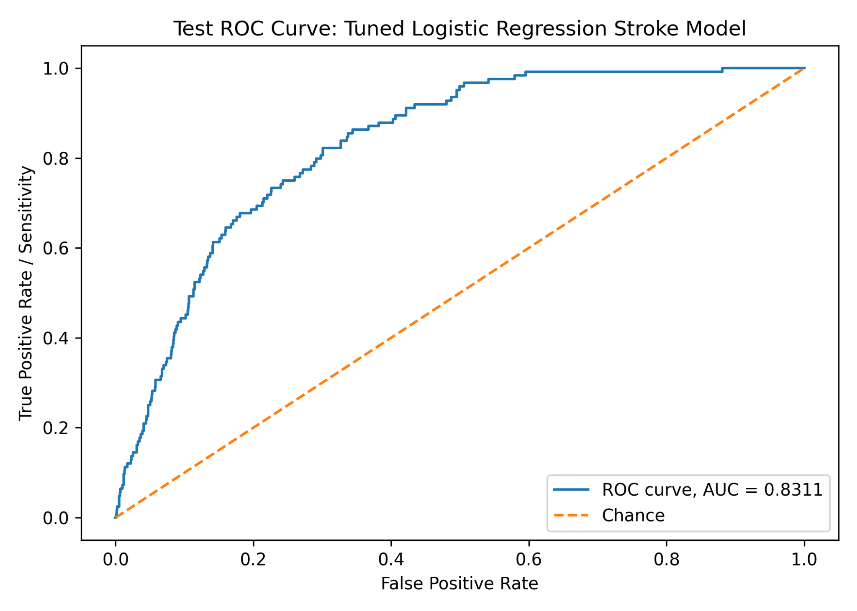
Figure 1. Test ROC curve for the tuned logistic regression stroke model. Test ROC-AUC = 0.8311.
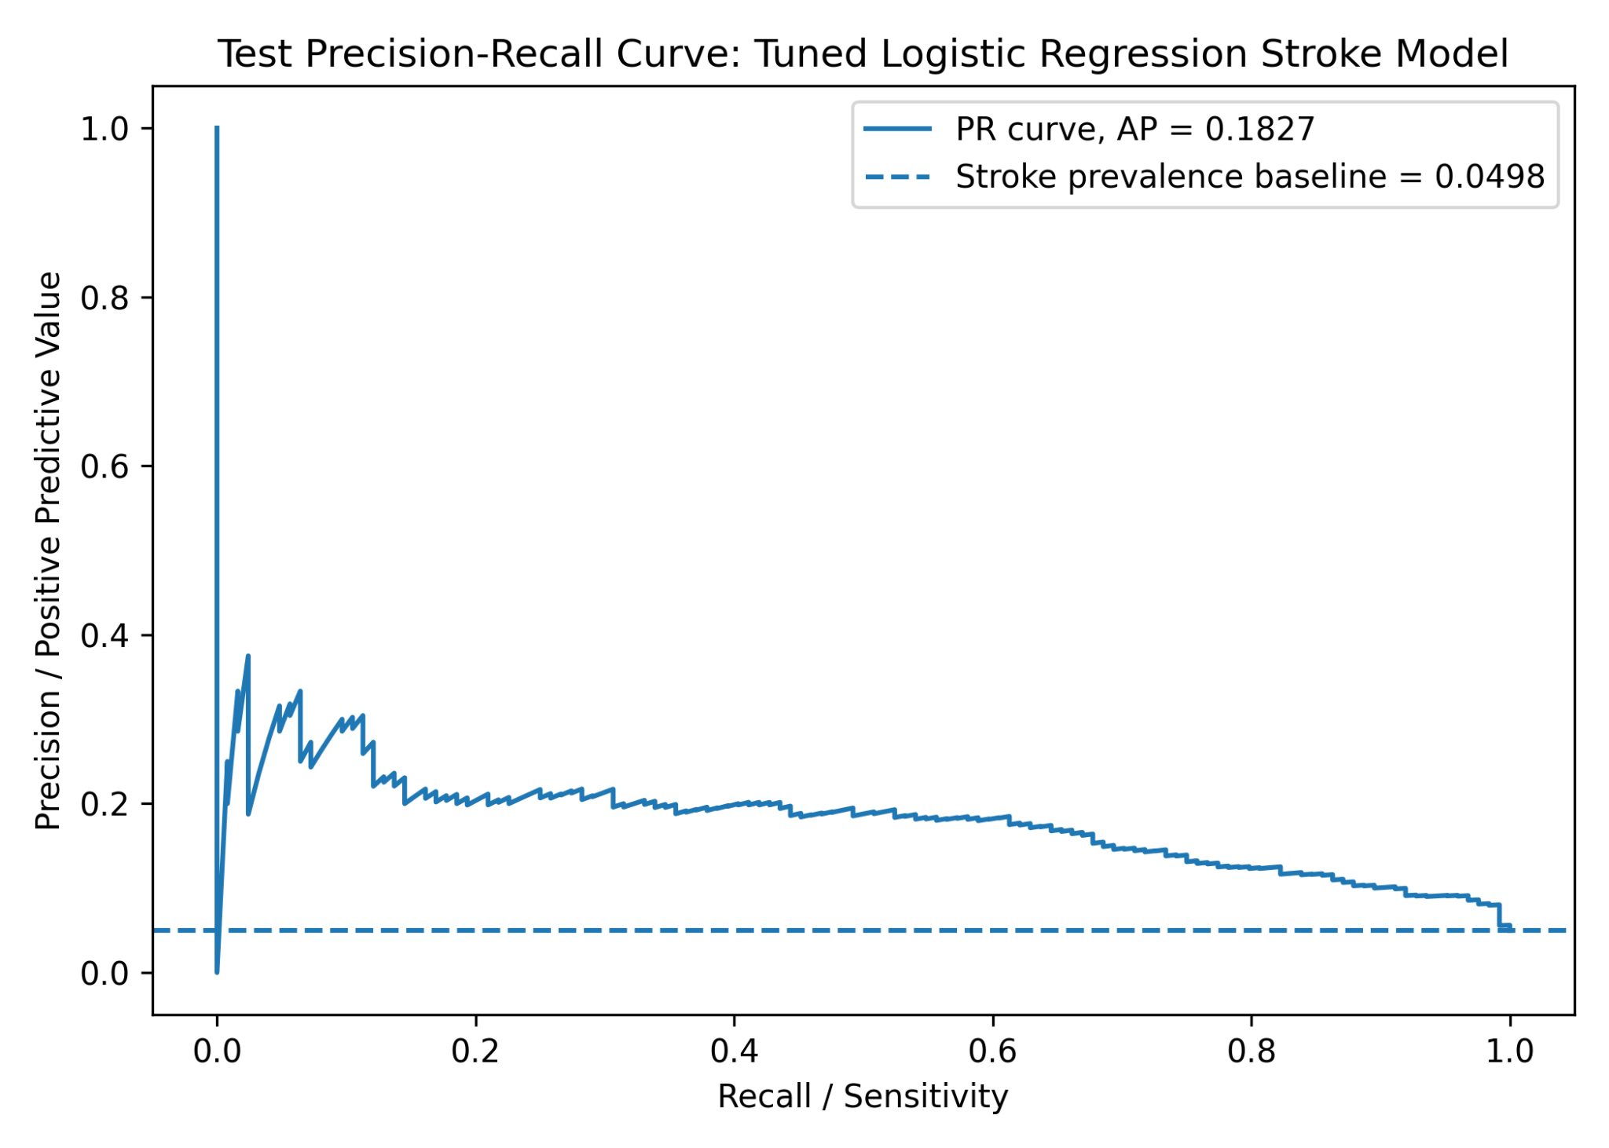
Figure 2. Test precision-recall curve for the tuned logistic regression stroke model. Average precision = 0.1827; stroke prevalence baseline = 0.0498.

Exploratory ROC-Based Threshold Selection
The threshold was selected using Youden's J statistic, calculated as sensitivity + specificity - 1. The selected threshold maximized the combined balance of sensitivity and specificity on the test ROC curve. Because this threshold was selected directly from the test set, it should be treated as exploratory rather than finalized for clinical use.
Selected Threshold | Sensitivity | Specificity | Youden's J
0.460510 | 0.8226 | 0.6992 | 0.5218

Performance Comparison: Default vs. Exploratory ROC Threshold
Threshold | Accuracy |  | Precision / PPV | Recall / Sensitivity |  | Specificity |  | F1-score | NPV |  | Balanced Accuracy
Default 0.50 | 0.7363 |  | 0.1304 | 0.7581 |  | 0.7351 |  | 0.2225 | 0.9831 |  | 0.7466
Exploratory ROC threshold 0.460510 | 0.7053 |  | 0.1253 | 0.8226 |  | 0.6992 |  | 0.2175 | 0.9869 |  | 0.7609
Threshold |  | TN |  |  | FP |  | FN |  |  | TP
Default 0.50 |  | 1,740 |  |  | 627 |  | 30 |  |  | 94
Exploratory ROC threshold 0.460510 |  | 1,655 |  |  | 712 |  | 22 |  |  | 102
Lowering the threshold from 0.50 to 0.460510 increased sensitivity from 0.7581 to 0.8226 and reduced false negatives from 30 to 22. However, it also increased false positives from 627 to 712 and reduced specificity from 0.7351 to 0.6992.

Threshold Comparison Table
Threshold | Accuracy |  | Precision |  | Recall / Sensitivity |  | Specificity |  | F1-score
0.10 | 0.2425 |  | 0.0612 |  | 0.9919 |  | 0.2032 |  | 0.1153
0.20 | 0.4071 |  | 0.0769 |  | 0.9919 |  | 0.3764 |  | 0.1428
0.30 | 0.5335 |  | 0.0913 |  | 0.9355 |  | 0.5125 |  | 0.1664
0.40 | 0.6383 |  | 0.1088 |  | 0.8710 |  | 0.6261 |  | 0.1934
0.50 | 0.7363 |  | 0.1304 |  | 0.7581 |  | 0.7351 |  | 0.2225
0.460510 | 0.7053 |  | 0.1253 |  | 0.8226 |  | 0.6992 |  | 0.2175
Threshold |  | FP |  | FN |  | TN |  | TP
0.10 |  | 1,886 |  | 1 |  | 481 |  | 123
0.20 |  | 1,476 |  | 1 |  | 891 |  | 123
0.30 |  | 1,154 |  | 8 |  | 1,213 |  | 116
0.40 |  | 885 |  | 16 |  | 1,482 |  | 108
0.50 |  | 627 |  | 30 |  | 1,740 |  | 94
0.460510 |  | 712 |  | 22 |  | 1,655 |  | 102
The threshold table shows the tradeoff between sensitivity and specificity. Very low thresholds capture nearly all stroke cases but create a very large number of false positives. Higher thresholds reduce false positives but miss more stroke cases.

Generalization Compared With Training Cross-Validation
Metric | Training CV | Test Set at 0.50 | Change / Note
Accuracy | 0.7390 | 0.7363 | Very similar.
Precision | 0.1395 | 0.1304 | Slight decrease.
Recall / Sensitivity | 0.8227 | 0.7581 | Lower on test set at the default threshold.
Specificity | 0.7346 | 0.7351 | Nearly unchanged.
F1-score | 0.2382 | 0.2225 | Slight decrease.
ROC-AUC | 0.8426 | 0.8311 | Small decrease, suggesting reasonable generalization.
PR-AUC | 0.2160 | 0.1827 | Decrease; precision remains a concern.
The tuned logistic regression model generalized reasonably but not perfectly. ROC-AUC stayed fairly close, decreasing from 0.8426 in training cross-validation to 0.8311 on the test set. At the default 0.50 threshold, sensitivity dropped from 0.8227 to 0.7581, meaning the model missed more stroke cases on the test set than expected from training cross-validation. The exploratory ROC threshold restored sensitivity to 0.8226, but with more false positives and lower specificity.

Clinical Interpretation and Limitations
- The model may be useful as a stroke risk-screening support model when sensitivity is prioritized.
- The model is not clinically ready and should not be used as a standalone diagnostic tool.
- Stroke cases are rare, around 5% of the test dataset, which makes precision difficult and makes PR-AUC highly relevant.
- Precision remains low, so many predicted stroke-positive cases are false positives.
- The threshold selected from the test ROC curve is exploratory and should not be treated as a finalized clinical threshold.
- Additional validation, calibration assessment, clinical review, and external validation would be needed before real-world use.

Output Files Recorded
File | Purpose | Notes
test_roc_curve(1).png | ROC curve figure | Shows test ROC-AUC of 0.8311.
test_precision_recall_curve(1).png | Precision-recall curve figure | Shows average precision of 0.1827 compared with stroke prevalence baseline of 0.0498.
test_logistic_regression_metrics(1).csv | Test performance metrics | Contains default-threshold, selected-threshold, and threshold comparison metrics.
test_predictions_logistic_regression(1).csv | Patient-level model output | Contains actual stroke values, predicted probabilities, and predicted classes at selected thresholds.

Research Question Linkage
The main research question asks: what factors have the most significant influence or relationship to brain stroke probability? The current model evaluation supports that the tuned logistic regression model has reasonable discrimination on the test dataset, so the previously generated model coefficients and odds ratios can be summarized as model-associated factors. However, these are associations with predicted stroke probability, not causal effects. Also, because the scikit-learn logistic regression output did not provide p-values or confidence intervals, the report should avoid saying that these variables are statistically significant unless a separate statistical inference step is performed.

Step 4: Summary and Interpretation Focused on Research Question
The prompt below produced a structured, report-ready interpretation answering the research question while clearly separating model association from causation and statistical significance.

Prompt Used
You are a medical data analyst writing the summary and interpretation section for an AI-assisted brain stroke prediction analysis.
Key research question:
"What factors have the most significant influence or relationship to brain stroke probability?"
Use the current project results and attached analysis files to write a clear interpretation. Use the following files if available:
- `logistic_regression_odds_ratios(1).csv`
- `logistic_regression_cv_results(1).csv`
- `test_logistic_regression_metrics(1).csv`
- `test_predictions_logistic_regression(1).csv`
Project context:
- The original dataset had 4,981 records and 248 stroke cases.
- The data were split 50/50 into training and testing sets using stratified sampling.
- Training set: 2,490 records, 124 stroke cases, stroke prevalence 4.9799%.
- Test set: 2,491 records, 124 stroke cases, stroke prevalence 4.9779%.
- The selected model was a tuned balanced logistic regression model with C = 0.01.
- Training cross-validation ROC-AUC was 0.8426 and PR-AUC was 0.2160.
- Test ROC-AUC was 0.8311 and test PR-AUC / Average Precision was 0.1827.
- At the default 0.50 threshold, test sensitivity was 0.7581 and specificity was 0.7351.
- At the exploratory ROC threshold of 0.460510, test sensitivity was 0.8226 and specificity was 0.6992.
- The strongest positive model coefficients from the tuned logistic regression were:
- age: coefficient 1.1434, odds ratio 3.1373
- avg_glucose_level: coefficient 0.1929, odds ratio 1.2128
- hypertension: coefficient 0.1474, odds ratio 1.1588
- heart_disease: coefficient 0.1086, odds ratio 1.1148
- smoking_status = smokes: coefficient 0.0906, odds ratio 1.0948
- bmi: coefficient 0.0254, odds ratio 1.0257
Important interpretation rules:
1. Answer the research question directly.
2. Rank the factors most strongly associated with higher predicted stroke probability based on the logistic regression coefficients and odds ratios.
3. Clearly separate model association from causation. Do not claim these factors cause stroke.
4. Do not claim statistical significance unless p-values or confidence intervals are actually calculated. If they are not available, say these are the strongest model-associated predictors, not statistically confirmed significant predictors.
5. Explain that numerical variables were standardized, so odds ratios for age, average glucose level, and BMI represent a one-standard-deviation increase.
6. Explain that categorical variable effects are interpreted relative to their reference categories.
7. Include a short explanation of why age appears to be the dominant factor.
8. Explain how average glucose level, hypertension, heart disease, smoking status, and BMI relate to predicted stroke risk in the model.
9. Summarize the model's predictive performance and what it means for trusting the factor interpretations.
10. Mention the class imbalance problem and the low precision problem.
11. Explain why the model is more appropriate as a screening-support tool than as a standalone diagnostic tool.
12. Include limitations, including:
- observational dataset
- no causal inference
- possible confounding
- possible missing variables
- imbalanced outcome
- low precision / many false positives
- threshold selected from the test ROC curve is exploratory
- need for calibration assessment and external validation
13. Recommend improvements for a stronger final analysis, including:
- confidence intervals and p-values for odds ratios using an appropriate statistical model
- calibration curve and Brier score
- multicollinearity check, such as VIF
- subgroup/fairness analysis by age group, sex, or other clinically relevant groups
- comparison with additional models such as random forest, gradient boosting, or XGBoost
- model explainability using permutation importance or SHAP
- validation on an external dataset
Required output format:
A. Executive summary in plain language
B. Direct answer to the research question
C. Ranked table of factors associated with higher predicted stroke probability
D. Interpretation of each major factor
E. Model performance summary
F. Clinical meaning and screening-use interpretation
G. Limitations
H. Recommended next improvements
I. Final conclusion paragraph
Keep the tone professional and suitable for an academic data analysis report.

AI Response / Results Received
The latest AI output summarized the completed tuned balanced logistic regression analysis in relation to the research question. The key conclusion was that age had the strongest positive association with predicted stroke probability, followed by average glucose level, hypertension, heart disease, current smoking, and BMI.
Source tracked in this update: Pasted text.txt, containing the Step 4 executive summary, factor interpretation, model performance summary, limitations, and final conclusion.

A. Executive Summary in Plain Language
The tuned balanced logistic regression model suggests that age is the strongest factor associated with higher predicted brain stroke probability in this dataset. Other factors associated with higher predicted stroke probability were average glucose level, hypertension, heart disease, current smoking, and BMI, in that order.
These results should be interpreted as model associations, not proof that the variables cause stroke. No p-values or confidence intervals were calculated in the current machine learning workflow, so the factors should be described as the strongest model-associated predictors rather than statistically confirmed significant predictors.
The model showed reasonable discrimination on the untouched test dataset, with a test ROC-AUC of 0.8311 compared with a training cross-validation ROC-AUC of 0.8426. However, because stroke cases were rare, precision remained low. The model is therefore best viewed as a stroke risk-screening support model, not a standalone diagnostic tool.

B. Direct Answer to the Research Question
Research question: What factors have the most significant influence or relationship to brain stroke probability?
Based on the tuned balanced logistic regression model, the strongest model-associated factors for higher predicted stroke probability were age, average glucose level, hypertension, heart disease, current smoking status, and BMI. Among these, age was the dominant predictor: its coefficient was much larger than the others, and its odds ratio was approximately 3.14 for a one-standard-deviation increase in age, holding other model variables constant.
These are predictive associations from the model, not causal conclusions.

C. Ranked Factors Associated With Higher Predicted Stroke Probability
Rank | Factor | Coefficient | Odds Ratio | Interpretation
1 | Age | 1.1434 | 3.1373 | Strongest positive association with predicted stroke probability.
2 | Average glucose level | 0.1929 | 1.2128 | Higher glucose was associated with higher predicted stroke probability.
3 | Hypertension | 0.1474 | 1.1588 | Hypertension was associated with higher predicted stroke probability.
4 | Heart disease | 0.1086 | 1.1148 | Heart disease was associated with higher predicted stroke probability.
5 | Smoking status = smokes | 0.0906 | 1.0948 | Current smoking was associated with higher predicted stroke probability.
6 | BMI | 0.0254 | 1.0257 | Higher BMI had a small positive association with predicted stroke probability.
Age, average glucose level, and BMI were standardized, so their odds ratios represent the change in predicted odds of stroke for a one-standard-deviation increase in the variable. Categorical effects should be interpreted cautiously because the pipeline used one-hot encoding with handle_unknown="ignore" and no explicit dropped reference category was specified.

D. Interpretation of Each Major Factor
Factor | Result | Interpretation
Age | Coefficient 1.1434; OR 3.1373 | A one-standard-deviation increase in age was associated with about 3.14 times higher model-estimated odds of stroke. Age was the dominant model factor.
Average glucose level | Coefficient 0.1929; OR 1.2128 | A one-standard-deviation increase in glucose was associated with about a 21.3% increase in model-estimated stroke odds.
Hypertension | Coefficient 0.1474; OR 1.1588 | Hypertension was associated with higher predicted stroke probability, with an estimated 15.9% increase in model-estimated odds.
Heart disease | Coefficient 0.1086; OR 1.1148 | Heart disease had a smaller positive association with predicted stroke probability.
Current smoking | Coefficient 0.0906; OR 1.0948 | Current smoking was associated with modestly higher predicted stroke probability. Because it is categorical and one-hot encoded, interpretation should remain cautious.
BMI | Coefficient 0.0254; OR 1.0257 | BMI had the smallest positive association among the listed factors, with only about a 2.6% increase in model-estimated odds per standard deviation.
Age likely appeared dominant because stroke risk generally increases with biological aging and because age may correlate with vascular disease, hypertension, metabolic changes, and other clinical risk factors. In this model, age retained the largest positive coefficient even after accounting for the other available variables.

E. Model Performance Summary
Selected model: Tuned Balanced Logistic Regression, C = 0.01. The model was trained using the training dataset only and evaluated on the untouched testing dataset.
Dataset | Records |  | Stroke Cases |  | Stroke Prevalence
Original dataset | 4,981 |  | 248 |  | 4.98%
Training set | 2,490 |  | 124 |  | 4.9799%
Test set | 2,491 |  | 124 |  | 4.9779%
Metric | Training Cross-Validation |  | Test Set |  | Interpretation
ROC-AUC | 0.8426 |  | 0.8311 |  | Slight decrease; discrimination generalized reasonably well.
PR-AUC / Average Precision | 0.2160 |  | 0.1827 |  | Decreased on test set; rare-class performance and precision remain concerns.
Metric |  | Default Threshold 0.50 |  | Exploratory ROC Threshold 0.460510
Accuracy |  | 0.7363 |  | 0.7053
Precision / PPV |  | 0.1304 |  | 0.1253
Recall / Sensitivity |  | 0.7581 |  | 0.8226
Specificity |  | 0.7351 |  | 0.6992
F1-score |  | 0.2225 |  | 0.2175
Negative Predictive Value |  | 0.9831 |  | 0.9869
Balanced Accuracy |  | 0.7466 |  | 0.7609
TN |  | 1,740 |  | 1,655
FP |  | 627 |  | 712
FN |  | 30 |  | 22
TP |  | 94 |  | 102
At the default threshold of 0.50, the model detected about 75.8% of stroke cases but had precision of only 13.0%. At the exploratory ROC threshold of 0.460510, sensitivity increased to about 82.3% and false negatives decreased from 30 to 22, but false positives increased from 627 to 712. The ROC-based threshold was selected using Youden's J statistic and should be considered exploratory because it was selected directly from the test set.

F. Clinical Meaning and Screening-Use Interpretation
The model is most appropriate as a stroke risk-screening support model. Its main strength is identifying a relatively high proportion of stroke cases, especially at the exploratory ROC threshold. Its main weakness is low precision, meaning many patients predicted as stroke-positive were false positives.
- High sensitivity may be useful for screening because missing possible stroke-risk patients can be serious.
- Low precision means the model should not be used alone to diagnose stroke or make clinical decisions.
- Positive predictions should be treated as signals for further review, not as definitive classifications.
- The model may help prioritize patients for additional assessment, but it is not clinically ready.

G. Limitations
Limitation | Why It Matters
Observational dataset | Associations can be identified, but causal relationships cannot be proven.
No causal inference | Model coefficients should not be interpreted as evidence that the factors directly caused stroke.
No p-values or confidence intervals | The workflow used scikit-learn logistic regression for prediction, so the odds ratios are not statistically confirmed significance results.
Possible confounding | Age may be related to hypertension, heart disease, glucose level, marital status, work type, and other variables.
Possible missing variables | Important clinical predictors may be absent, such as prior stroke history, diabetes diagnosis, cholesterol, blood pressure values, atrial fibrillation, medication use, physical activity, family history, imaging findings, or socioeconomic variables.
Imbalanced outcome | Only about 5% of records were stroke cases, making accuracy misleading and precision difficult to achieve.
Low precision and many false positives | At the default threshold there were 627 false positives; at the exploratory ROC threshold there were 712.
Exploratory threshold selection | The ROC-based threshold was selected from the test set, so it should not be treated as a finalized clinical threshold.
Need for calibration assessment | Discrimination was assessed, but probability calibration was not evaluated.
Need for external validation | The model was evaluated only on a split from the same original dataset and should be tested on outside data.

H. Recommended Next Improvements
Improvement | Purpose
Estimate confidence intervals and p-values for odds ratios | Use an appropriate statistical logistic regression model, such as statsmodels, to assess statistical significance.
Assess calibration | Add a calibration curve and Brier score to evaluate whether predicted probabilities match observed stroke risk.
Check multicollinearity | Use variance inflation factors to assess whether predictors are highly correlated.
Perform subgroup and fairness analysis | Evaluate performance by age group, sex, smoking status, residence type, or other clinically relevant groups.
Compare with additional models | Compare logistic regression with random forest, gradient boosting, XGBoost, or other models that may capture nonlinear relationships.
Use explainability methods | Apply permutation importance or SHAP values to better understand feature influence.
Use training-based threshold selection | Select thresholds using training cross-validation predictions or a separate validation set, then evaluate once on the untouched test set.
Externally validate the model | Test the final model on data from another hospital, population, or time period.
Include more clinical variables if available | Add predictors such as diabetes diagnosis, systolic blood pressure, cholesterol, atrial fibrillation, medication use, prior stroke history, and family history.

I. Final Conclusion Paragraph
The tuned balanced logistic regression model identified age as the strongest factor associated with predicted brain stroke probability, followed by average glucose level, hypertension, heart disease, current smoking, and BMI. These factors should be interpreted as predictive associations from the model, not as causal effects or statistically confirmed significant predictors. The model showed reasonable generalization from training cross-validation to the untouched test set, with test ROC-AUC of 0.8311, but its low precision indicates that many predicted stroke-positive cases were false positives. Because stroke was rare in the dataset, the model is better suited as a screening-support tool that may help identify patients who warrant further clinical review rather than as a standalone diagnostic model. Additional statistical inference, calibration assessment, fairness analysis, comparison with other models, and external validation are needed before considering real-world clinical application.

Suggested Next Analysis Direction
The most logical next step is to strengthen the factor interpretation by estimating p-values and confidence intervals for odds ratios, checking multicollinearity, and assessing probability calibration. This would help distinguish model-associated predictors from statistically supported predictors and evaluate whether predicted risks are numerically trustworthy.

